**School Code: 71710 School Affiliation No.: 2133540**



**HTML WEB PAGE**

**CLASS X**

**Project report submitted to**

**SETH. M.R. JAIPURIA SCHOOL, ORAI**

**Aff. To C.B.S.E. (NEW DELHI)**

**Signature (Guide): Submitted by Om Saini**

**Name of the Guide: Name of student: Om Saini**

**Mr. Surya Narayan Sharma Adm. No.: A/JS/2223/OR/0031**

**ACKNOWLEDGEMENT**

I wish to express my deep gratitude and sincere thanks to Principal **Mr. D.T. RAJU** for his encouragement and all the facilities which she provided for the included project work. I sincerely appreciate this magnanimity by taking me into his folds for which I shall remain indebted to his.

I extend my hearty thanks to **Mr. Surya Narayan Sharma** who guided me to the successful completion of this project. I offer my sincere thanks to my classmates too, who helped me to carry out this work successfully.

**Class – 10thA**

**CERTIFICATE**

This is to certify that Project details recorded in this Practical File have been performed by ……………………………………..of **X (A)** of **Seth. M.R. Jaipuria School** during the academic session **2022-2023**.

_________________ _____________ _______________

**Examiner Sign Principal Sign Teacher Sign**

|  |  |  |
| --- | --- | --- |
| **S.No.** | **Topic** | **Page No.** |
|  | **Project -1** |  |
|  | **Project -2** |  |
|  | **Project -3** |  |
|  | **Project -4** |  |
|  | **Project -5** |  |
|  | **Project -6** |  |
|  | **Project -7** |  |
|  | **Project -8** |  |
|  | **Project -9** |  |
|  | **Project -10** |  |

**Index**

**PROJECT - 1**

**Write a code to show the following output:**

**Solution:**

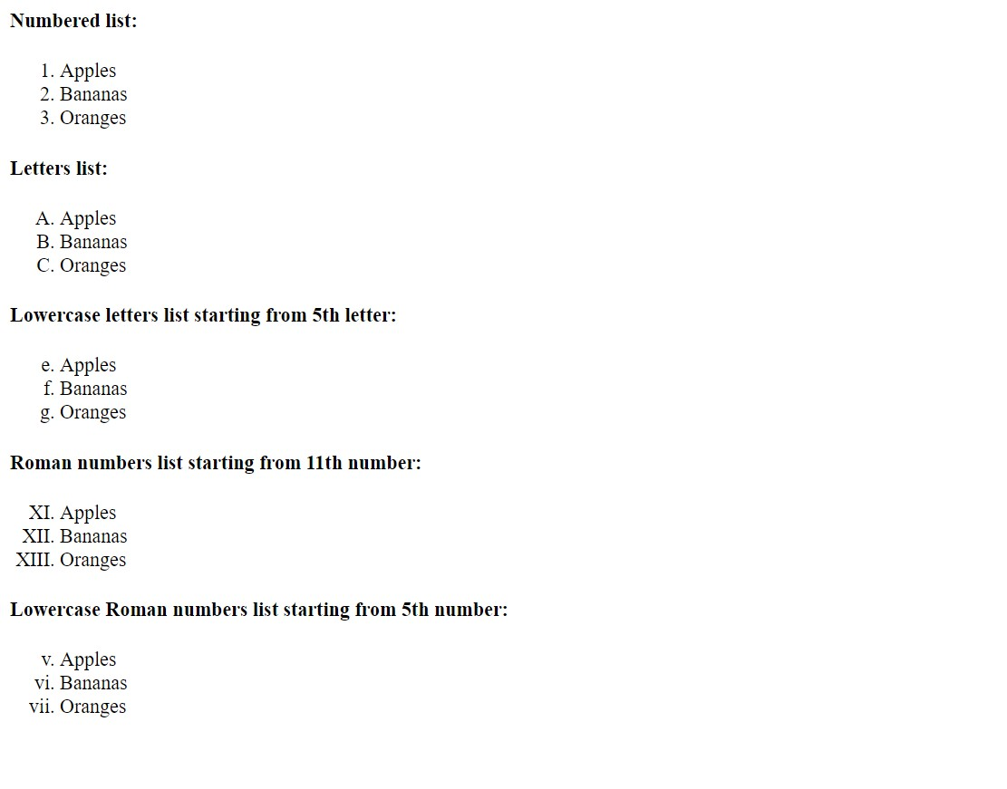

<HTML>

<HEAD>

<TITLE> Many Ordered Lists</TITLE>

</HEAD>

<BODY>

<H4>Numbered list:</H4>

<OL>

<LI>Apples</LI>

<LI>Bananas </LI>

<LI>Oranges</LI>

</OL>

<H4>Letters list:</H4>

<OL type = "A">

<LI>Apples</LI>

<LI>Bananas</LI>

<LI>Oranges</LI>

</OL>

<H4>Lowercase letters list starting from 5th letter:</H4>

<OL type = "a" start = 5>

<LI>Apples</LI>

<LI>Bananas</LI>

<LI>Oranges</LI>

</OL>

<H4>Roman numbers list starting from 11th number:</H4>

<OL type="I" start = 11>

<LI>Apples</LI>

<LI>Bananas</LI>

<LI>Oranges</LI>

</OL>

<H4> Lowercase Roman numbers list starting from 5th number:</H4>

<OL type="i" start = 5>

<LI>Apples</LI>

<LI>Bananas</LI>

<LI>Oranges</LI>

</OL>

</BODY>

</HTML>

**Result:**

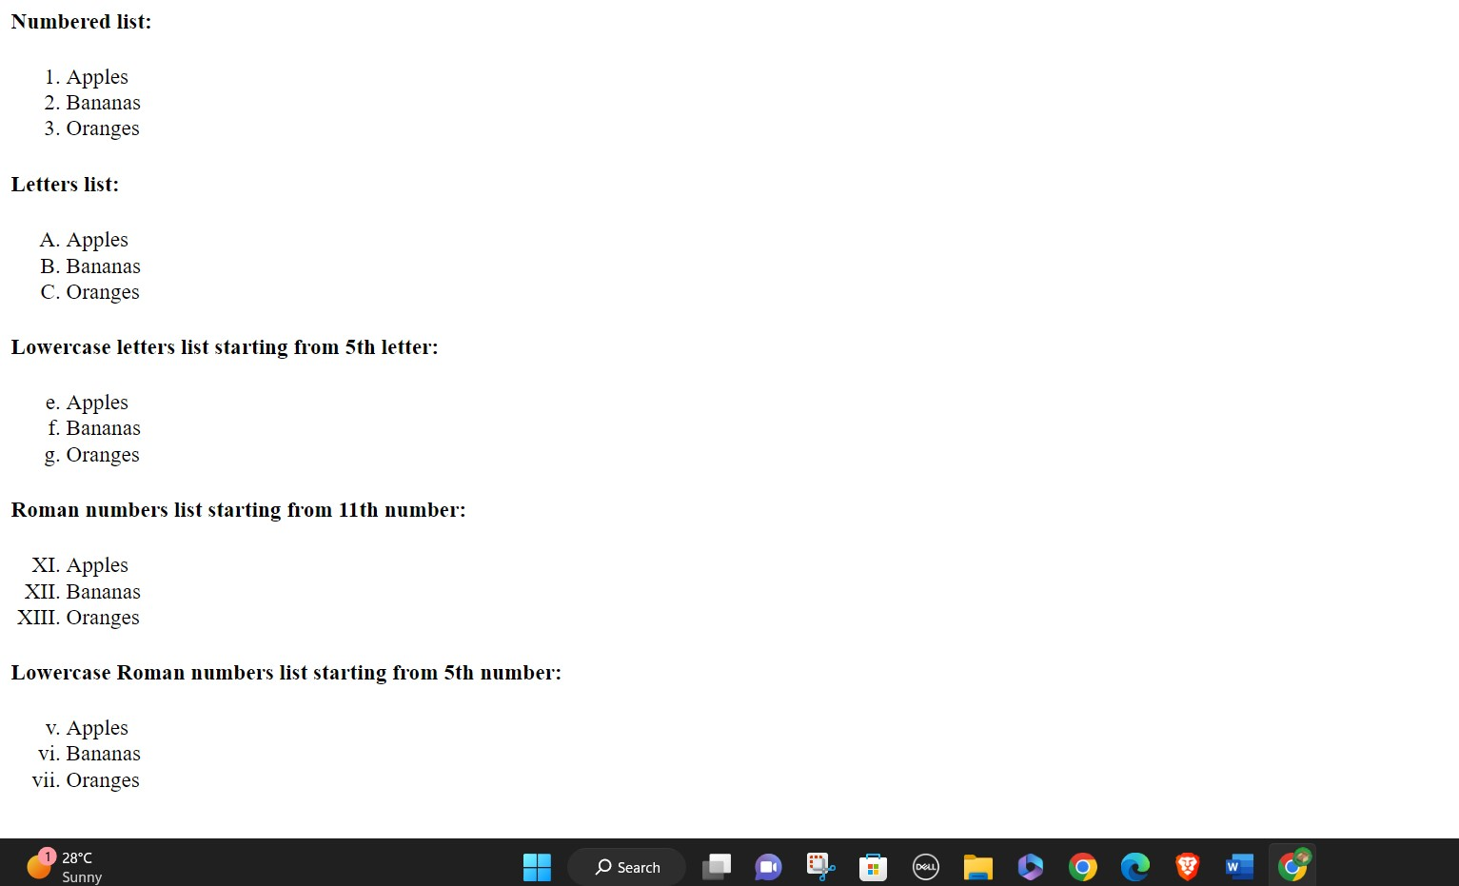

**PROJECT – 2**

**Observe the following HTML webpage and generate a code for it:**

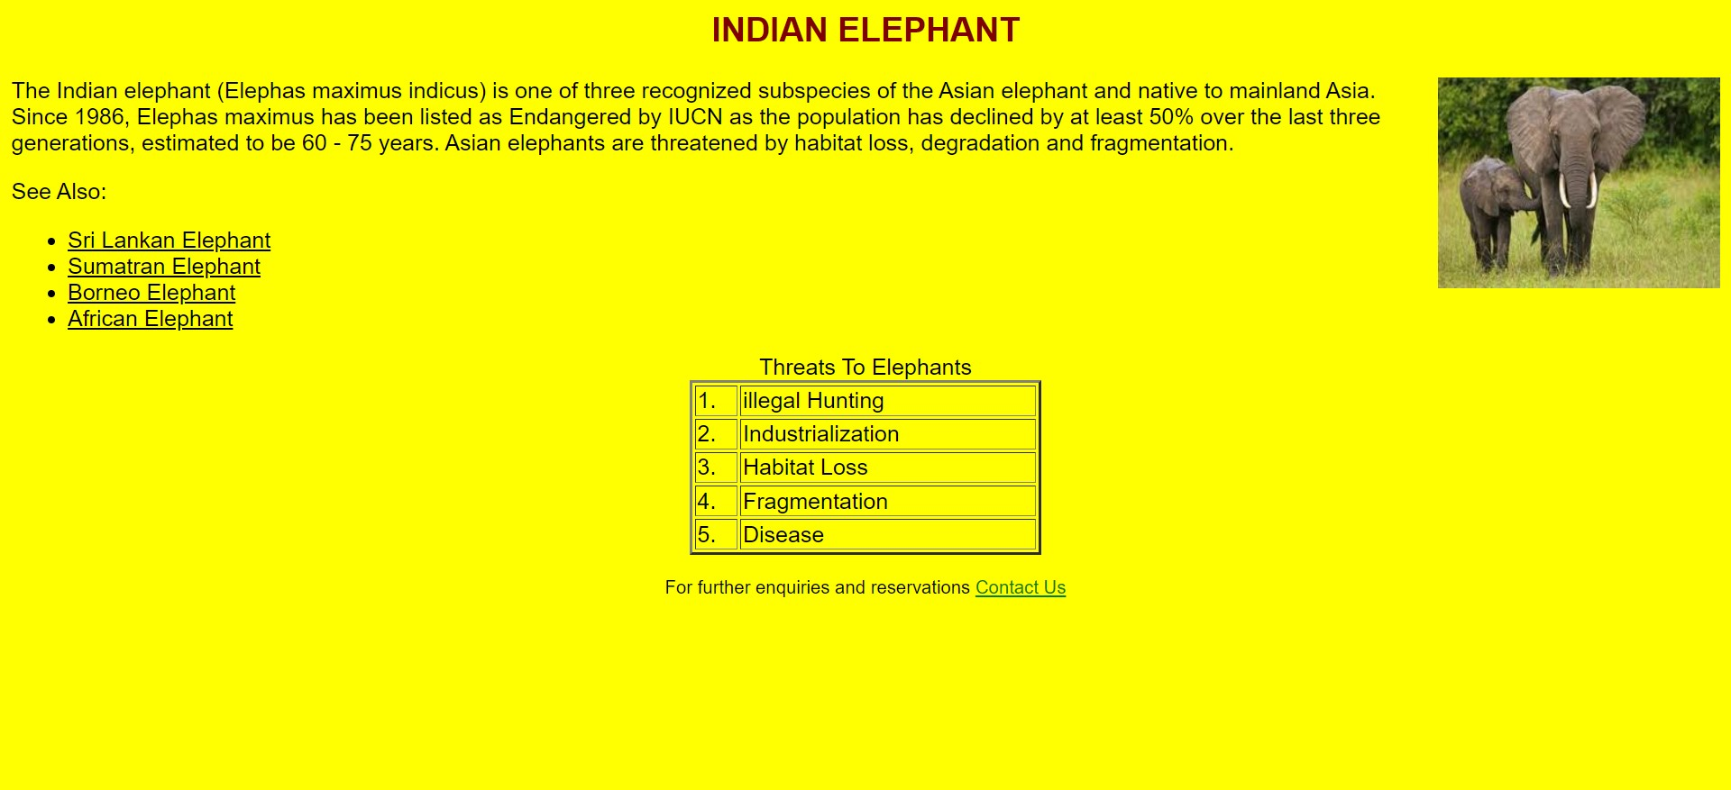

**Solution:**

<HTML>

<HEAD>

<TITLE> </TITLE>

</HEAD>

<BODY bgcolor="yellow" link="black" vlink = "green">

<FONT face=" "Arial" color= "maroon">

<H2 align="center"> INDIAN ELEPHANT </H2> </FONT>

<FONT face=" "Arial">

<IMG src=" .png" height ="150" width =^ prime prime 200 ^ prime prime align="right">

The Indian elephant (Elephas maximus indicus) is one of three recognized subspecies of the Asian elephant and native to mainland Asia. Since 1986, Elephas maximus has been listed as Endangered by IUCN as the population has declined by at least 50% over the last three generations, estimated to be 60 75 years. Asian elephants are threatened by habitat loss, degradation and fragmentation.

<P>

See Also:

<UL>

<LI> <A href="one.html"> Sri Lankan Elephant </A> </LI>

<LI> <A href "two.html"> Sumatran Elephant </A> </LI> <LI> <A href="three.html"> Borneo Elephant </A> </LI>

<LI> <A href "four.html"> African Elephant </A></ LI >

</UL>

<TABLE align="center" border="2" width =^ prime prime 250 ^ prime prime >

<CAPTION>Threats To Elephants </CAPTION>

<TR> 1 </TD>

<TD> Illegal Hunting </TD>

</TR>

<TR> 2 </ TD >

<TD> Industrialization </ TD >

</TR>

<TR> 3 </TD>

<TD> Habitat Loss </TD>

</TR>

<TR> 4 </TD>

<TD> Fragmentation </TD>

</TR>

<TR> 5</ TD >

<TD> Disease </TD>

</TR>

</TABLE>

<P> <P>

<FONT size =^ prime prime 2 ^ prime prime > <CENTER> For further enquiries and reservations

<A href = "abc@xyz.com"> Contact Us </ A > </CENTER>

</BODY>

</HTML>

**Result:**

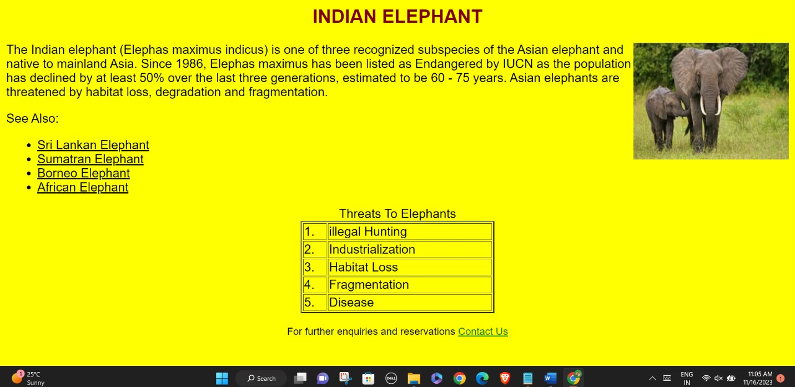

**PROJECT - 3**

**Write a code to show the following output:**

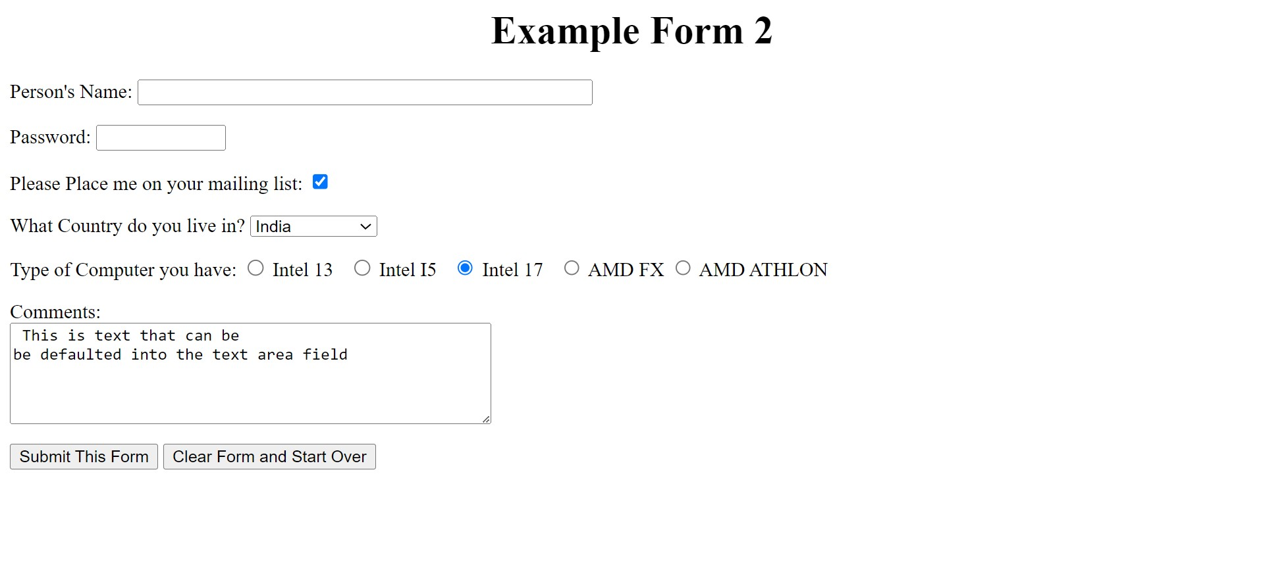

**Solution:**

<HTML>

<BODY>

<P ALIGN= Center>

<CENTER> <H1>Example Form 2</H1></CENTER>

</P>

<Form METHOD = POST >

<P>Person's Name:

<INPUT TYPE="text" NAME = "persons -name" SIZE="40" MAXLENGTH="40">

<INPUT TYPE="hidden" NAME = "recipient" SIZE="40" MAXLENGTH = "40">

</P>

<P>Password:

<INPUT TYPE = "password" NAME = "password" SIZE="10" MAXLENGTH="10">

</P>

<P>Please Place me on your mailing list :

<INPUT TYPE = "checkbox" NAME = "mailing-list" VALUE = "Yes" checked>

</P>

<P>What Country do you Live in?

<SELECT NAME = "Country">

<OPTION VALUE = "IND">India

<OPTION VALUE = "USA">United States

<OPTION VALUE="CA">Canada

<OPTION VALUE="FR">France

<OPTION VALUE = "SPR">Singapore

</SELECT>

</P>

<P>Type of Computer you have :

<INPUT TYPE="radio" NAME="Comp-Type" VALUE="Inteli3" /> Intel 13 &nbsp;

<INPUT TYPE="radio" NAME = "Comp-Type" VALUE="Inteli5" /> Intel I5 &nbsp;

<INPUT TYPE="radio" NAME = "Comp-Type" VALUE="Inteli7" checked /> Intel I7 &nbsp;

<INPUT TYPE="radio" NAME="Comp-Type" VALUE="AMDFX" /> AMD FX

<INPUT TYPE="radio" NAME="Comp-Type" VALUE="AMDATHLON" /> AMD ATHLON

</P>

<P>Comments: <br>

<TEXTAREA ROWS = "5" COLS = "50" NAME="comments"> This is text that can be be defaulted into the text area field </TEXTAREA>

</P>

<P>

<INPUT TYPE="submit" NAME = "Request" VALUE="Submit This Form">

<INPUT TYPE = "reset" NAME="Clear" VALUE="Clear Form and Start Over">

</P>

</FORM>

</BODY>

</HTML>

**Result:**

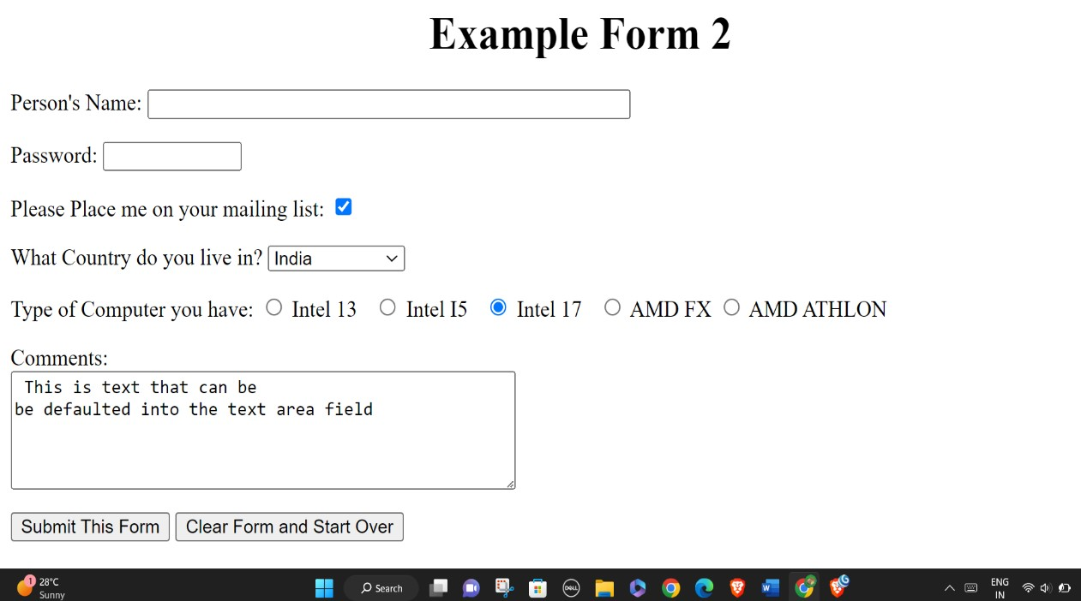

**PROJECT - 4**

**Write the HTML code to generate a web page in style and format shown below.**

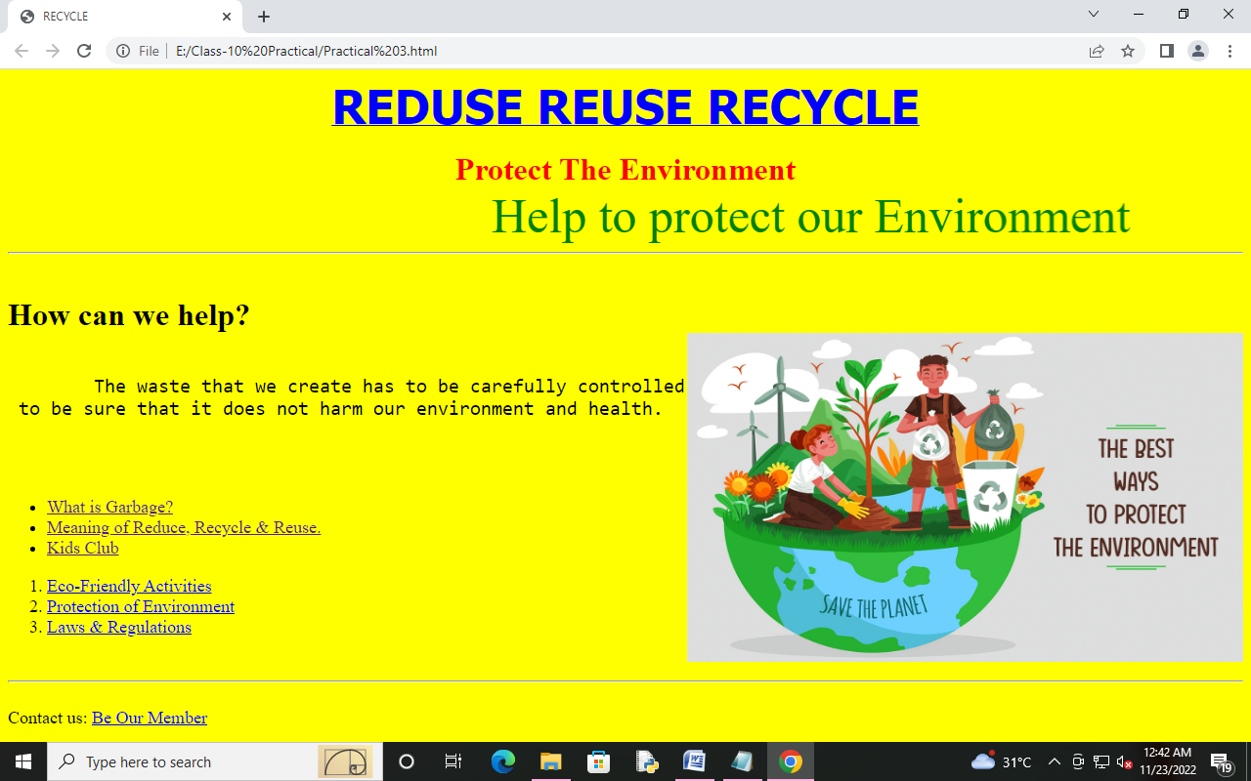

**INSTRUCTIONS**

* The title of the page is “Recycle Reuse Reduce”.
* The background color of the page is ‘Light Yellow’.
* The font used for the Heading is “Thoma”, size is 6 and color is Blue.
* The sub heading is Verdana font and the color of Red. Rest of the text is in Arial Black font.
* Apply marquee style to “Help to protect our Environment…” after the heading Protect the Environment.
* The name of the image is “The-Best-Ways-To-Protect-The-Environment”. It is aligned to the right with text flowing to the left of the screen.
* The text, “How can we help?”, is a heading with level 2.
* The links are provided in an Unordered List, with the Ordered List used in between.
* The pages are linked as follows:
* What is Garbage? <https://www.epa.gov/recycle>
* Meaning of Reduce, Recycle & Reuse: <https://www.ohiovalleywaste.com/ohio-valley-waste-news/reduce-reuse-recycle-what-does-it-mean-3049>
* Kids Club <https://www.natgeokids.com/uk/category/kids-club/>
* Eco-Friendly Activities: <https://www.parentcircle.com/easy-eco-friendly-environment-day-activities/article>
* Protection of Environment: <https://powermin.gov.in/en/content/protection-environment>
* Laws & Regulations: <https://www.epa.gov/laws-regulations>
* Be our member: <mailto:RecycleClub@gmail.com>
* Place a horizontal line across the webpage.

**PROJECT -5**

**Creating a webpage with table containg colspan and rowspan attribute as following.**

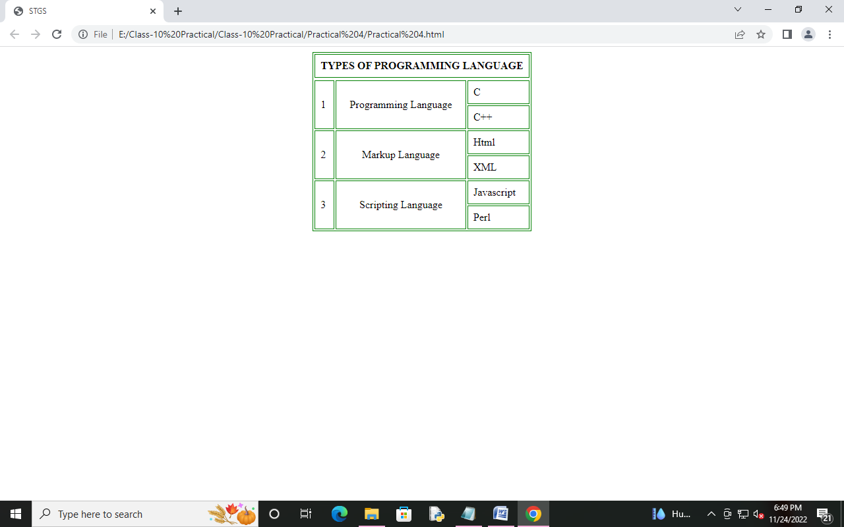

**PROJECT-6**

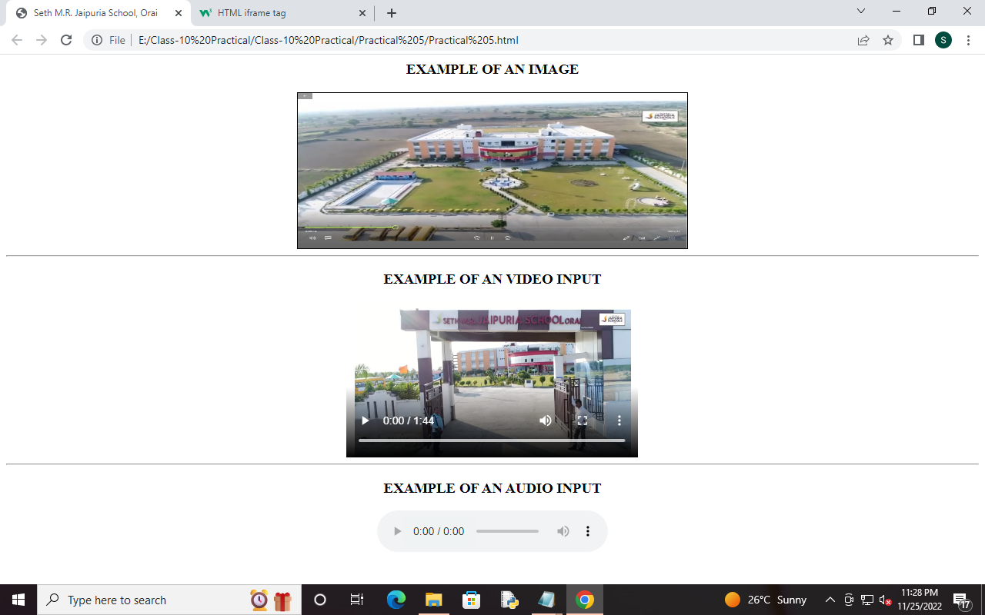**Creating a webpage with multimedia elements (image, audio, and video).**

**PROJECT -7**

**Create a webpage of a website using text, image and hyperlink as per the following output.**

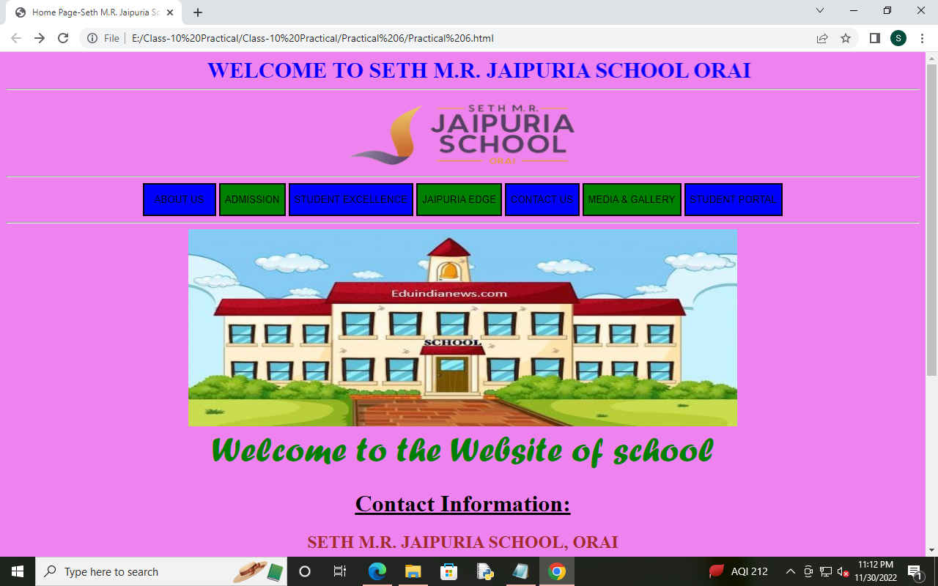

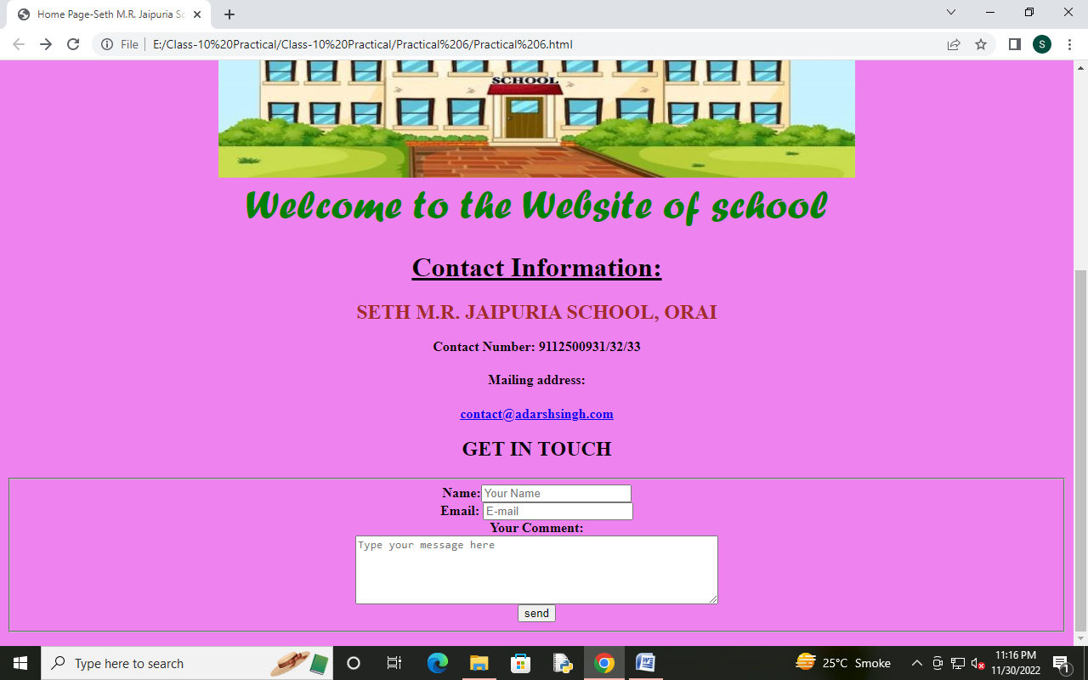

* The buttons are linked as following link :
* ABOUT US: https://www.jaipuriaschoolorai.in/about-us/
* ADMISSION: <https://www.jaipuriaschoolorai.in/admissions/>
* STUDENT EXCELLENCE: <https://www.jaipuriaschoolorai.in/student-excellence/>
* JAIPURIA EDGE: <https://www.jaipuriaschoolorai.in/jaipuria-edge/>
* CONTACT US: https://www.jaipuriaschoolorai.in/contact-us/
* MEDIA & GALLERY: https://www.jaipuriaschoolorai.in/media-gallery/
* STUDENT PORTAL: https://jsorai.edunext3.com/Index

**PROJECT -8**

**Create a webpage as per the following for student admissions form.**

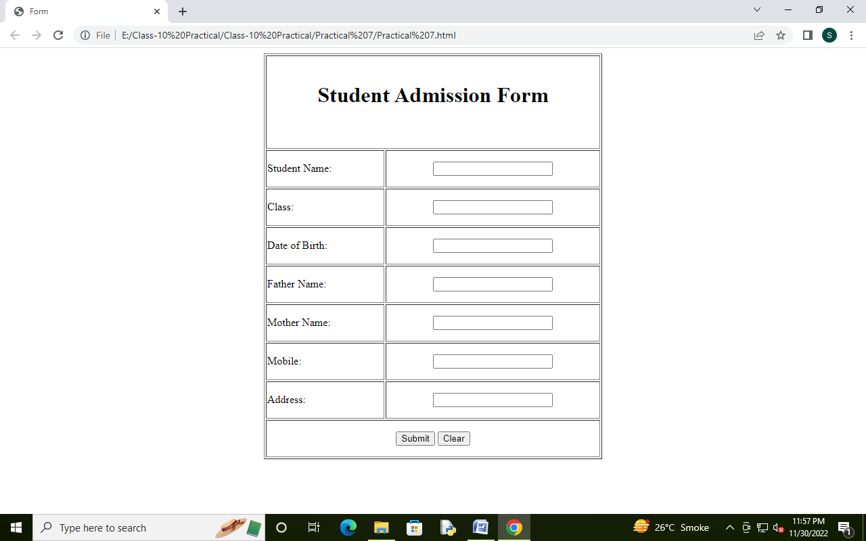

|  |  |
| --- | --- |
|  |  |
|  |  |
|  |  |
|  |  |
|  |  |
|  |  |
|  |  |
|  |  |
|  |  |
|  |  |
|  |  |
|  |  |
|  |  |
|  |  |
|  |  |
|  |  |
|  |  |
|  |  |
|  |  |
|  |  |
|  |  |
|  |  |
|  |  |
|  |  |
|  |  |
|  |  |
|  |  |
|  |  |
|  |  |
|  |  |
|  |  |
|  |  |
|  |  |
|  |  |
|  |  |
|  |  |
|  |  |
|  |  |
|  |  |
|  |  |
|  |  |
|  |  |
|  |  |
|  |  |
|  |  |

**PROJECT-9**

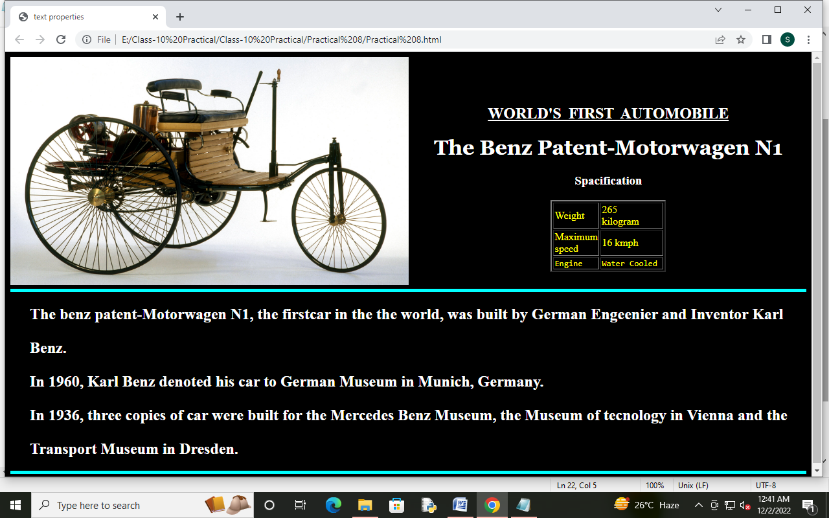**Write the HTML code to generate a webpage in style and format shown below.**

**INSTRUCTIONS**

* The background colour of the page is 'white'.
* Use the following CSS for heading and paragraph.
* P{Font-weight:bold;Text-indent:30px;Line-height:1.5;}
* H2{Text-align:center;Text-decoration:underline;text-transform:Capitalize; Word-spacing:5px;}
* H1{Font-family: Georgia;Text-align:center;}
* H3{Text-align:center; Color:Red; Letter-spacing:5px;}
* The name of the image is "first_car". It is aligned to the left with height 55% and width is 50%.

**PROJECT-10**

**Write the HTML code to generate a webpage in style and format shown below.**

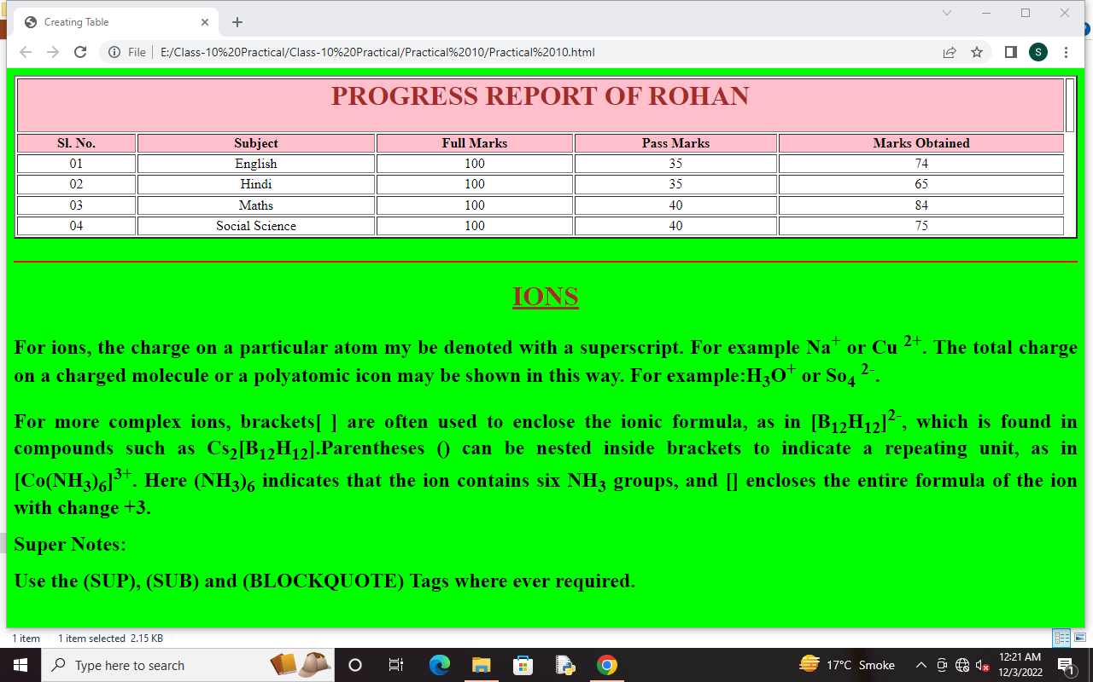

**PROJECT-11**

**Write the HTML code to generate a webpage for quiz questions and link button to check the answer as format shown below.**

**INSTRUCTIONS**

**When we click on the link SUBMIT AND CHECK YOUR ANSWER the following webpage will appear to check the answer and when we click on the link BACK TO HOME PAGE the user will move to first (home) page.**

